[**How to Use a Blender**](https://www.wikihow.com/Use-a-Blender)

Shortly this wonderful appliance will be your best friend. After a few experiments, you'll wonder what you can't make with this thing. And all you do is press a button and go. See Step 1 below to get started making pretty much anything.

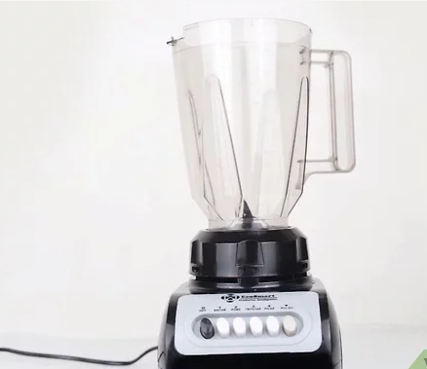

**1.Make sure the blender is plugged in, clean, and in working condition.**

You can pretty much eyeball this one -- if it looks like it's in okay condition, it's probably safe to use. Be sure to have dry hands, wet hands is a safety hazard with and electric appliance.

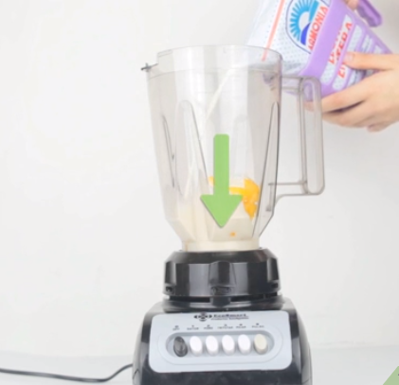

**2.Put your ingredients inside.**

We'll cover the things you can put inside in the next section, but for now just know that it all goes in there, pretty much however you want. It's a good idea to get a little liquid near the bottom to get everything going -- otherwise the solid stuff doesn't move around very easily.

If you're blending ice, you'll need a little bit of liquid to get it going. The ice floats in water, letting the blades do their thing. No water and the ice will just wedge itself against the sides, slowly melting. Never put boiling items in a blender it can shatter.

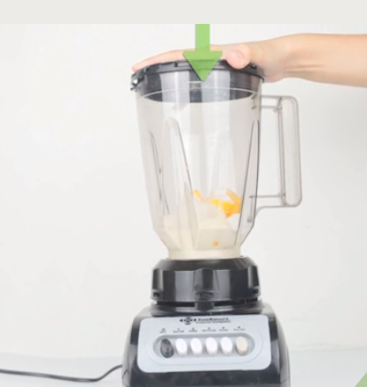

**3.Close the lid and hold the cover tightly.**

That little cap that comes off? That's the feeder cap. You can leave your blender going, remove the feeder cap, and add in a few more (albeit small) things if you'd like. But other than that, it's best to leave the lid on -- or else you might end up with blender goo on your walls.

If it doesn't start, make sure the bottom of the blender is placed securely in the base. If the base and the blender aren't meeting just so, it can't make the connection to start whizzing and whirring.

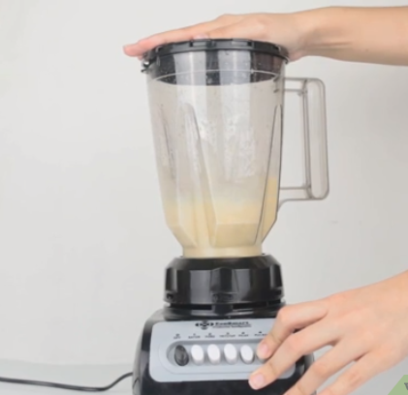

**4.Blend!**

Try experimenting with the buttons. Choose an appropriate speed setting depending on what you are blending. Generally speaking, the further you go to the right, the higher the speed. Never put a spoon or other utensil in the blender while it is running, be sure your blender is turned off before you use any utensil to stir.

Chop, grate, grind, blend, mix, stir, puree, whip, and liquefy -- don't worry too much about these. You can't really use any "incorrectly." If it isn't the consistency you want it to be, try a higher speed. If that doesn't work, stop the blender, take off the lid, mix it up, and start again.

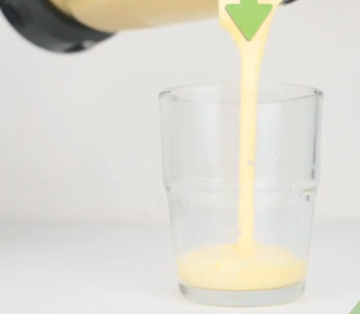

**5.Open it up and pour it out.**

If you're done that is. You may need to scrape out the bottom or undo the blades to get it all out of there, especially if it's thick. That's it!

**6.Clean the blender.**

Remove the blender from the base and wash the two parts separately. Just run the top under warm water with a little soap; the blades are sharp so be careful not to cut yourself.

Never, ever, ever put the base in water! If you get it gunky, take a wet cloth or sponge to it. It's hard to hurt it -- and water (or any other liquid) is really the only way.

Be sure to dry the blender completely, you don't want to leave liquid in the blender, its best to air dry upside down.